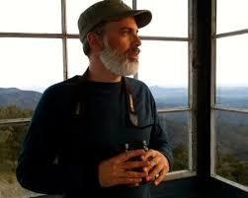


Featured this Month

The Mountain Knows the Mountain by Philip Connors

I wasn’t really sure what to expect when I got this book. The blurbs on the back dust cover suggested that the subjects inside would be nature, poetry, prose, comments on fire watching and introspection. That sounded interesting. Also, Mr. Connors, when he isn’t a fire watcher in the New Mexican Gila Wilderness, is our neighbor in Hillsboro.

Before I opened to the first page, I was thinking this book might be something like a combination of Walden, by H.D. Thoreau, and Robert Frost’s nature poetry, but with a Southwestern slant. Sort of like Richard Bradford's Red Sky at Morning might be considered an earlier New Mexico view of the themes in J.D. Salinger’s The Catcher in the Rye.

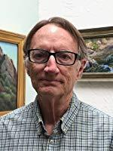
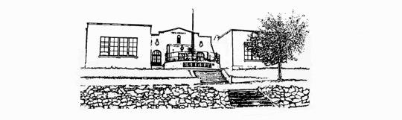

What I found is a book that is both cerebral and visceral. It contains a story that is both personal and universal. It, in places, made me smile from within, like Mona Lisa, and it made me think, which also made me smile. The author does include observations on nature, like Thoreau and Frost do, but from a current, curious mind. It includes, in between the mechanics of being a fire watcher, (which might, to some of us, seem to be an exercise in doing nothing while waiting for something to happen) the author includes observations on the process of writing, both prose and poetry, especially the compressed poetic forms of haiku and others. It includes thoughts about thinking, observations about seeing nature in its various raw, ever-changing forms, and comments on the evolution of the U.S. Forest Service policies to handle this country's National Forests, and the inevitable fires.

There are little asides here and there throughout the book. For instance:

“dead snags all around
relics of the old forest
woodpecker condos”

And comments on the fire watchers life:

“lazy vigilance
alert while doing nothing
harder than it looks”

However, if you aren’t a fan of poetry, this book is also a tremendously interesting view of what it is like to live almost completely alone for very long periods of time, (four months +/-) and how an intelligent, curious and active person adapts to that situation and and manages to appreciate and to really know everything that goes on in the area surrounding a fire watch station.

The physical book itself is a work of art. The illustrations subtly enhance the reading experience, with the smoke motif here and there throughout the book. If you like the idea of entering the mind of an intelligent, thoughtful, curious and compassionate human being, you will enjoy this book.
Review by Will KinneyFiction

New at the Library

Birdie by Tracey Lindberg
Born of Blood and Ash- Flesh and Fire Novel by Jennifer L. Armentrout
The Last Days of Night by Graham Moore
Orphans of War by Michael Reit
Soul of Blood and Ash- Blood and Ash Series by Jennifer Armentrout

Nonfiction
Atomic Women- The Untold Stories of the Scientists Who Helped Create the Nuclear Bomb by Roseanne Montillo
DNA USA- A Genetic Portrait of America by Vryan Sykes
Drawing On the Right Side of the Brain- A Course in Enhancing Creativity and Artistic Confidence by Betty Edwards
Georgia O’Keefe- The Late Work by Randall C. Griffin
Good Pictures Are a Strong Weapon- Laura Gilpin, Queerness, and Navajo Sovereignty by Louise Siddons
Harvey Girls- The Women Who Opened the West by Lesley Poling-Kempes
My Life in San Juan Pueblo- Stories of Esther Martinez by Esther Martinez, Sue-Ellen Jacobs and Josephine Binford
Nina Otero-Warren of Santa Fe by Charlotte Whaley
Outliers- The Story of Success by Malcolm Gladwell
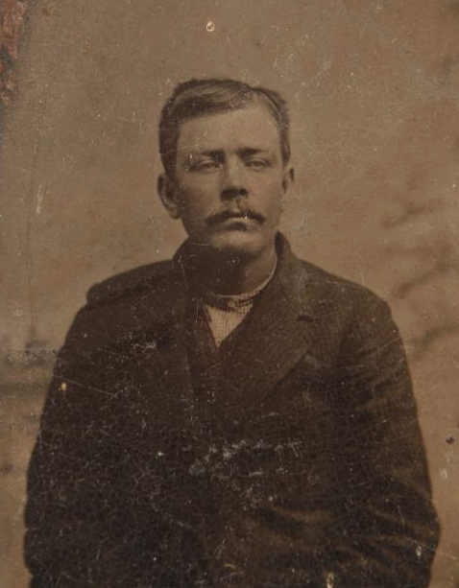
Park Ranger Sequel- More True Stories From a Ranger’s Career in America’s National Parks by Nancy Eileen Muleady-Mecham
The West Without Water- What Past Floods, Droughts, and Other Clamatic Clues Tell Us About
Tomorrow by B. Lynn Ingram and Frances Malamud-Roam

Wicked Women of New Mexico by Donna Blake Birchell
DVDs
Landman… Sinners

Mystery
Boar Island by Nevada Barr
A Dangerous Crossing by Ausma Zehanat Khan
Death on the Island by Eliza Reid
Exposure by Ramona Emerson
Heartwood by Amity Gaige
The Other Side of Death by Judith Van Gieson
The Rich People Have Gone Away by Regina Porter
The Unquiet Dead by Ausma Zehanat Khan
What We Can Know by Ian McEwan

Young Readers
Deb Haaland by Laurel Goodluck, Gillian Flint and Chelsea Clinton
Dolores Huerta by Monica Brown and Gillian Flint
Shaped By Her Hands- Potter Maria Martinez by Anna Harber Freeman, Barbara Gonzales, and Aphelandra
What Your Ribbon Skirt Means To Me- Deb Haaland’s Historic Inauguration by Alexis Bunten and Nicole Neidhardt

New at The Library
This month our Library presents the first of a continuing feature of books on a selected subject.
This month we will feature Influential Women of New Mexico. Ask your Librarian where to find the display.
For a complete listing of Library materials,
Visit:

https://hillsborolibrary.org
Bake Sale

The Library Bake Sale is on for
Saturdays
March 7 and April 4
10:00am -1:00pm
Come and get your goodies!

Bookmobile Schedule

Caballo at Caballo Country Store and RV Park
Thursdays Mar 19 and April 16
10:30 am -11:00 am

Kingston at Fire Station
Fridays Mar 27 and April 24
10:30 am- 11:15 am

https://nmstatelibrary.org/bookmobiles/west-bookmobile/

Library Hours:

Sunday, Monday: closed
Tuesday thru Saturday ~ 10:00am -3:00pm

Wi-Fi available all the time

Notes from the Library Board
Your Library Board has recently obtained free online books and movies available through Kanopy and Libby by OverDrive, as well as technology help for any non-tech savvy residents (like me) through GetSetup (where you can take online classes from our website). To get access to these new features all you need is a free Hillsboro Community Library membership card. This can be obtained by 1) visiting the Library during regular business hours of 10 am – 3 pm Tuesday through Saturday, or 2) calling the library during the above days and hours at (575) 895-3349, or 3) emailing the Library at hbolib@gmail.com

Please feel free to visit and see the changes and improvements that will be happening in the next few months.

We would like to thank our faithful Volunteer Librarians who have manned the desk for so many years. We will be counting on them as we transition to a New Mexico Public Library. We would also like to thank Frances and Bruce, who have coordinated the volunteer bakers and run the sale, as well as all of the bakers. The donations received for homemade baked goods is an important source of income for the Library.

Published by
the Hillsboro Community Library
P.O.Box 205, Hillsboro NM 88042 (575-895-3349)

