Volume 20: Number 5 September/ October, 2025

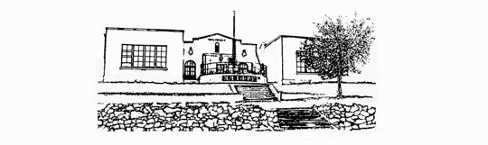
Featured this Month
The Beautiful Madness of Martin Bonham by Robert Hudson
This is a thoroughly enjoyable story of academic intrigue on a college campus, with very well written both male and female characters. It also made me think more deeply about the concept of “loving God”, which is the main bone of contention between the principle character, an English professor, and the head of the school’s Divinity department.
The setting is a small midwestern college, and although I didn’t attend one, the setting isn’t an impediment to enjoying the story. Nor would a reader’s unfamiliarity with college life make reading the story difficult. The author explains what isn’t apparent, and the characters inhabiting the story are so engaging everyone can understand and enjoy them.
This isn’t a particularly religious story, but it does perfectly capture life on a small college campus, with all it’s intrigues and beauty. The main character, English professor Martin Bonham, is a mixture of ancient and current knowledge, continually quoting from his favorite classic “mystic” writers and atypical current culture, which, like in real life, is often irritating to his friends, and amusing to outsiders. He is reminiscent of some professors I encountered in my university days.
The second of the three main characters is a young graduate Divinity student, Katie Wescott. She is the one who brings the sub-plot of “loving God, which runs throughout the story, to Professor Bonham. I found some parallels in their relationship with those of the older residents of our community (like me) with the younger ones establishing themselves here.
I also found myself comparing this story, favorably, with the wit and fun of Dorothy L. Sayers’ Peter

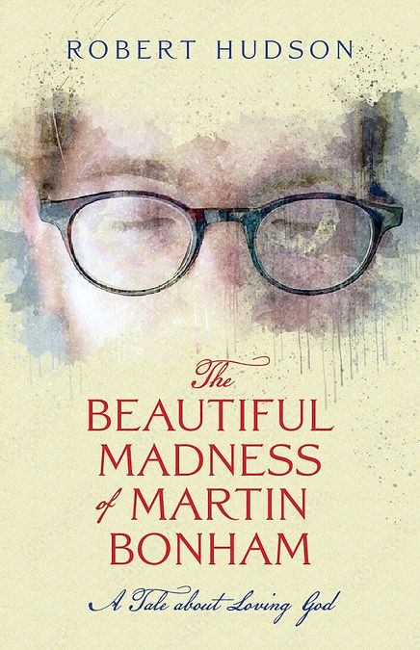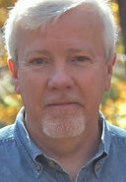

Wimsey stories and Laurie R. King’s Mary Russell series.
Robert Hudson has created some eccentric, interesting and completely believable characters, an engaging plot and a pleasantly thought provoking story.
He has also included an afterword with summaries of the writers quoted by most of the characters, many of which I was unaware, and am adding to my list of books I hope to read.
Review by Will Kinney

Library Hours:
Sunday closed Monday ~ 5:00pm - 8:00pm Tuesday ~ 2:00pm - 5:00pm Friday ~ 10:00am -1:00pm Thursday~ 2:00pm - 5:00pm Friday ~ 10:00am -1:00pm Saturday ~ 9:00am - 2:00pm

Fiction
The Fox- by Frederick Forsyth
New at the Library

Encyclical on Climate Change and Inequality- On

A Good Neighborhood- by Therese Fowler
The Guide to James Joyce’s Ulysses- by Patrick Hastings
The High Country- by William W. Johnstone and
J.A. Johnstone
Hotshot- by Julie Garwood
In the Shadows of the Sun- by Alexander Parsons
Isola- by Allegra Goodman
The Last Juror- by John Grisham Los Alamos- by Joseph Kanon Nightshade- by Michael Connelly Rabbit Cake- by Annie Hartnett
Remarkably Bright Creatures- by Shelby Van Pelt
Sparring Partners- by John Grisham
Testimony- by Scott Turow
When the Jessamine Grows- by Donna Everhart
The Whistler- by John Grisham

Nonfiction
American Earth- Environmental Writing Since Thoreau- by Bill McKibben and Al Gore
Atlas of Human Anatomy- by Frank H. Netter
Be Ready When the Luck Happens- a Memoir by Ina Garten
Believing in Place- a Spiritual Geography of the Great Basin- by Richard V. Francaviglia Birdsong- a Natural History- by Don Stap
Build Your Own Earth Oven- by Kiko Denzer and Hannah Field
Builder’s Greywater Guide- by Art Ludwig
By the Fire We Carry- the Generations-long Fight for Justice on Native Land by Rebecca Nagle Canoeing With the Cree- by Eric Sevareid
A Certain Idea of America- Selected Writings by Peggy Noonan
The Elements of the Aborigine Tradition- by James Cowan
Care for Our Common Home- by Pope Francis The Greed Line- Tool for a Just Economy- by Athena Peralta and Rogate R. Mshana
In the Sierra Madre- by Jeff Biggers
Inferno- Bill and Alice Wright Photography Series-
by Charles Bowden
The Lost City of the Monkey God- by Douglas J. Preston
The New Deal- A 75th Anniversary Celebration by Kathryn A. Flynn and Richard Polese
The New Ranch Handbook- Guide to Restoring Western Rangeland by Nathan Freeman Sayre Posture, Get it Straight- by Janice Novak
The Soldier’s Truth- Ernie Pyle and the Story of World War II by David Chrisinger
The Tecate Journals- Seventy Days on the Rio Grande by Keith Bowden

DVDs
Contact…The Doors…Herman Wouk’s The Winds of War… Lone Star… Sex and the City… Sex and the City-Season 2…The Wind that Shakes the Barley

Mystery
The Collector- by Daniel Silva
A Death in Cornwall- by Daniel Silva
Echo- by Tracy Clark
The House of Cross- by James Patterson The Judge’s List- by John Grisham Knave of Diamonds- by Laurie R. King No Accident - by Steven Havill
Perfect Opportunity- by Steven Havill Return to Sender- by Craig Johnson Tooth and Claw- by Craig Johnson

Poetry
How to Sing for Money- Poems by Connie Wanek

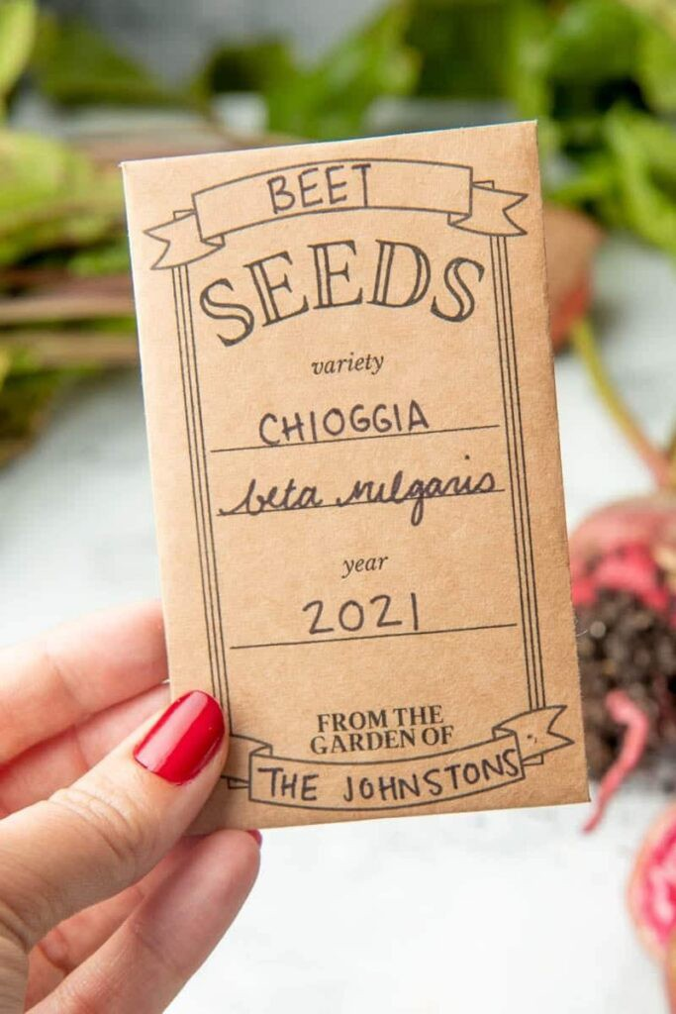
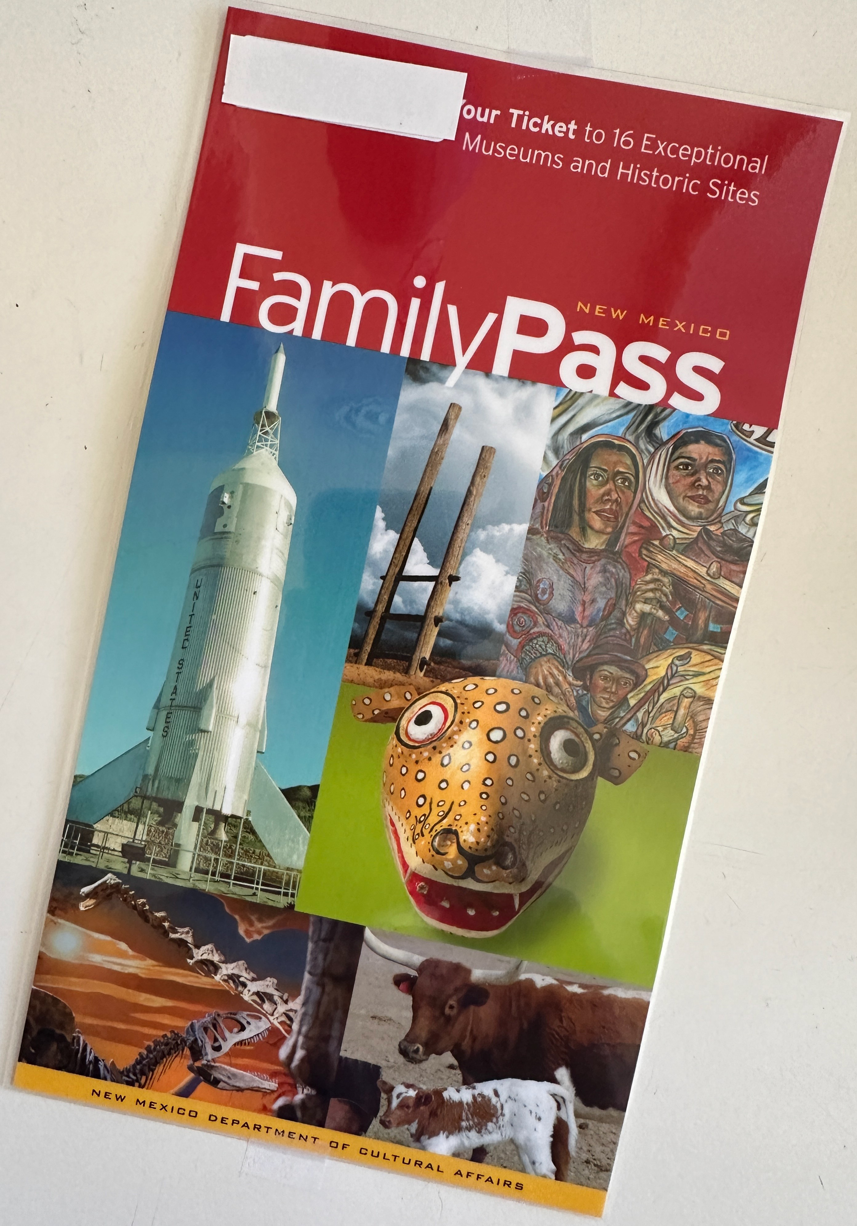
Notes from the Library Board
We are now your seed sharing library. Stop in and pick up envelopes so you can share seeds from your plants with others. What better way to help your fellow gardeners find veggies and flowers that grow and produce well in our climate?

Don’t forget to check out a family pass to visit museums and historic sites in New Mexico for free

Looking for some Monday evening fun? Join Meagan and Bill in the library for GAME NIGHTS from 5 until 8 pm
For a complete listing of Library materials, visit https://hillsborolibrary.org
Bookmobile Schedule
Thursday Sept 18
Lil Abner’s, Caballo 10:30am- 11:00am

Friday Sept 26
Hillsboro Post Office 9:15am-10:00am
Kingston Fire Station 10:30am-11:15am

https://nmstatelibrary.org/bookmobiles/west-bookmobile/
Bake Sale
The Library Bake Sale is on for
Saturdays, Sept 6 and Oct 4 10:00am -1:00pm
Come and get your goodies!

Published by
the Hillsboro Community Library
P.O.Box 205, Hillsboro NM 88042 (575-895-3349)

